PATTY HALL

NATIVE DAUGHTER OF THE GOLDEN WEST™

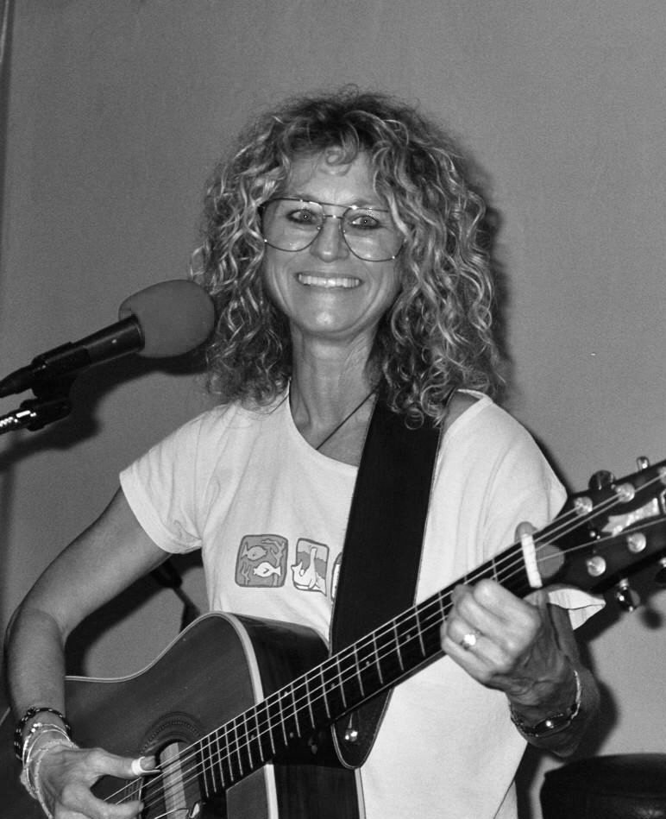

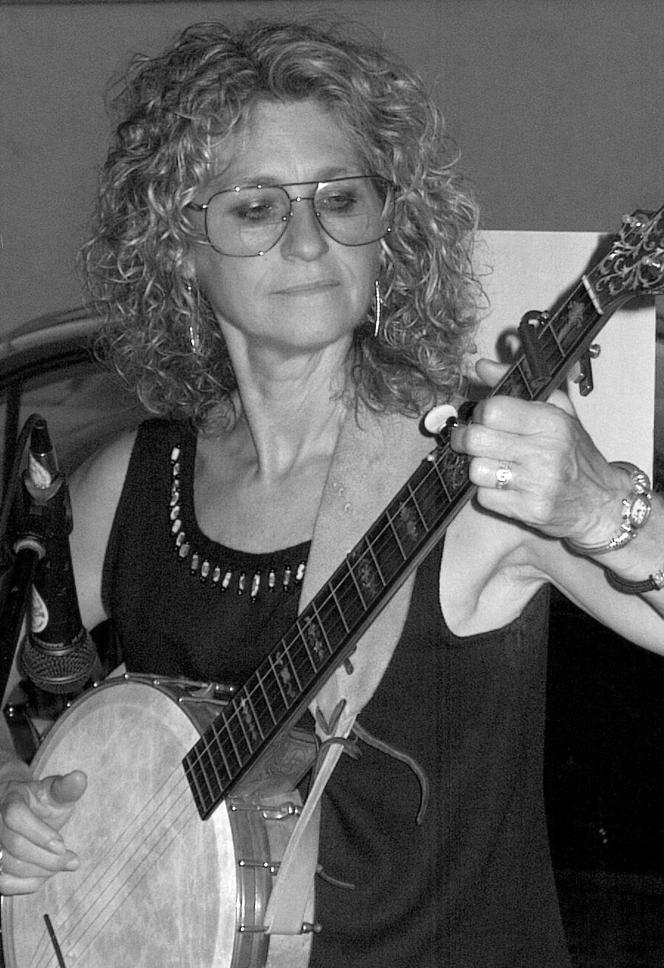

ESSENTIALS JUICE & JAVA

Santee, California

FRIDAY, OCTOBER 22, 2004
7:30 PM – 10:30 PM

PATTY HALL is a singer-songwriter and 4^{th-}generation Californian who is
back in her home state after 25 years in Music City, USA. Also a trained folklorist and children’s book author, Patty merges music with authorly and scholarly pursuits, blending it together in a fusion of original numbers, old-timey banjo tunes, funky girl blues, topical ballads and her very own JUMPIN UP!™ SONGS for kids—spiked with folkloric commentary and good humor. Join Patty and musical special guest GREG CAMPBELL for a night of memorable music at Essentials!

Patty will also be signing copies of her books she has written about

JOHNNY GRUELLE & RAGGEDY ANN & ANDY

ESSENTIALS JUICE & JAVA

245 Town Center Parkway (Mission Gorge East to Town Ctr Prkwy;

located in the Home Depot shopping center) Santee, CA / 619-448-3309

Visit Patty at http://www.pattyhall.com

